**BSQL Assignment 201**

**Questions to answer**:

**Q1:**

1. Create an EMPLOYEE table with the most appropriate/economic field/column constraints & types. All fields are mandatory except Note field.

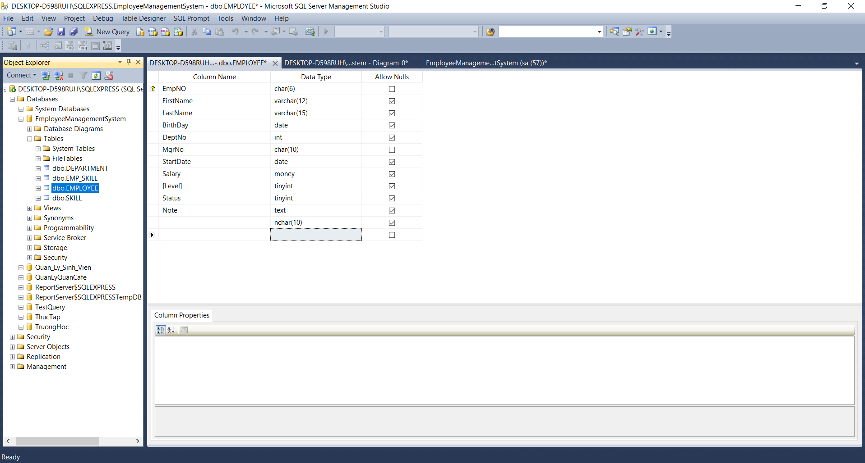

1. Create a SKILL table with the most appropriate/economic field/column constraints & types, all fields are mandatory except Note field.

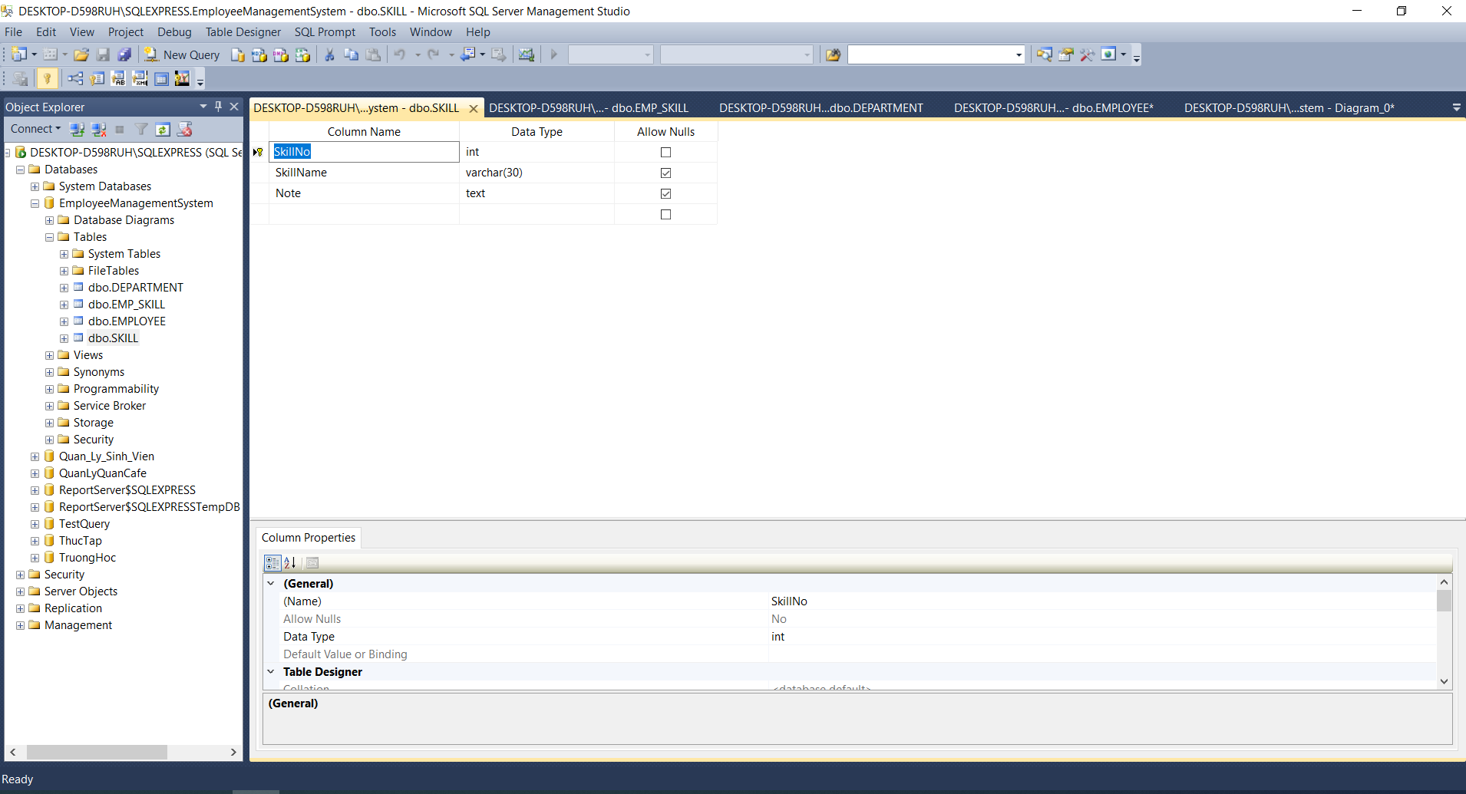

1. Create a DEPARTMENT table with the most appropriate/economic field/column constraints & types, all fields are mandatory except Note field.

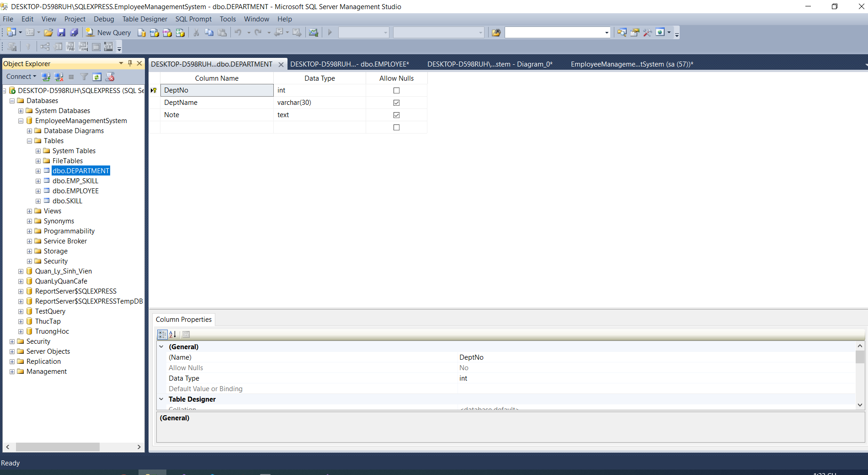

1. Create EMP_SKILL table with the most appropriate/economic field/colum constraints & types, all fields are mandatory except Description field.

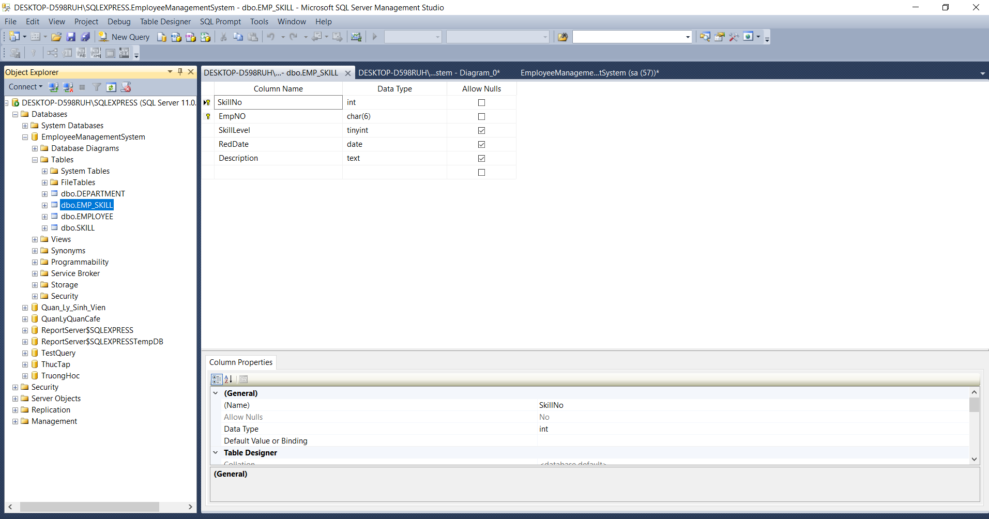

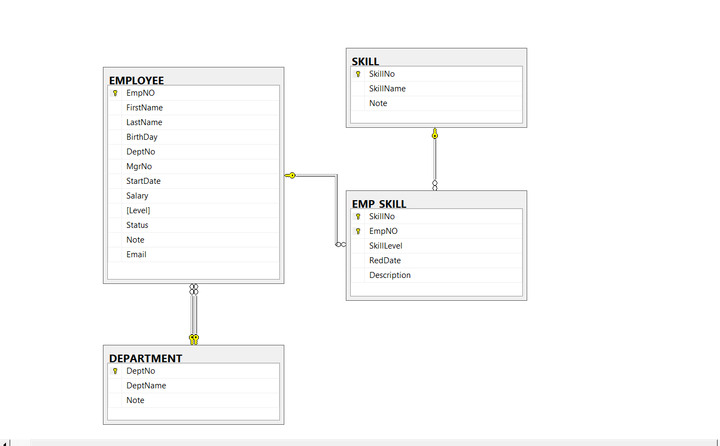

**Q2:**

1. Add an Email field to EMPLOYEE table and make sure that the database will not allow the value for Email to be inserted into a new row if that value has already been used in another row.

ALTER TABLE dbo.EMPLOYEE

ADD Email varchar(50) UNIQUE

**Q3**:

1. Add the FOREIGN KEY constrain of DeptNo field to the EMPLOYEE table that will relate the DEPARTMENT table.

ALTER TABLE dbo.EMPLOYEE ADD CONTRAINT Emp_DeptNo_FK

FOREIGN KEY (DeptNo) REFERENCES dbo.DEPARTMENT

1. Remove the Description field from the EMP_SKILL table.

ALTER TABLE dbo.EMP_SKILL

DROP COLUMN Description

**Q4**:

1. Add at least 5 records into each of the created tables.

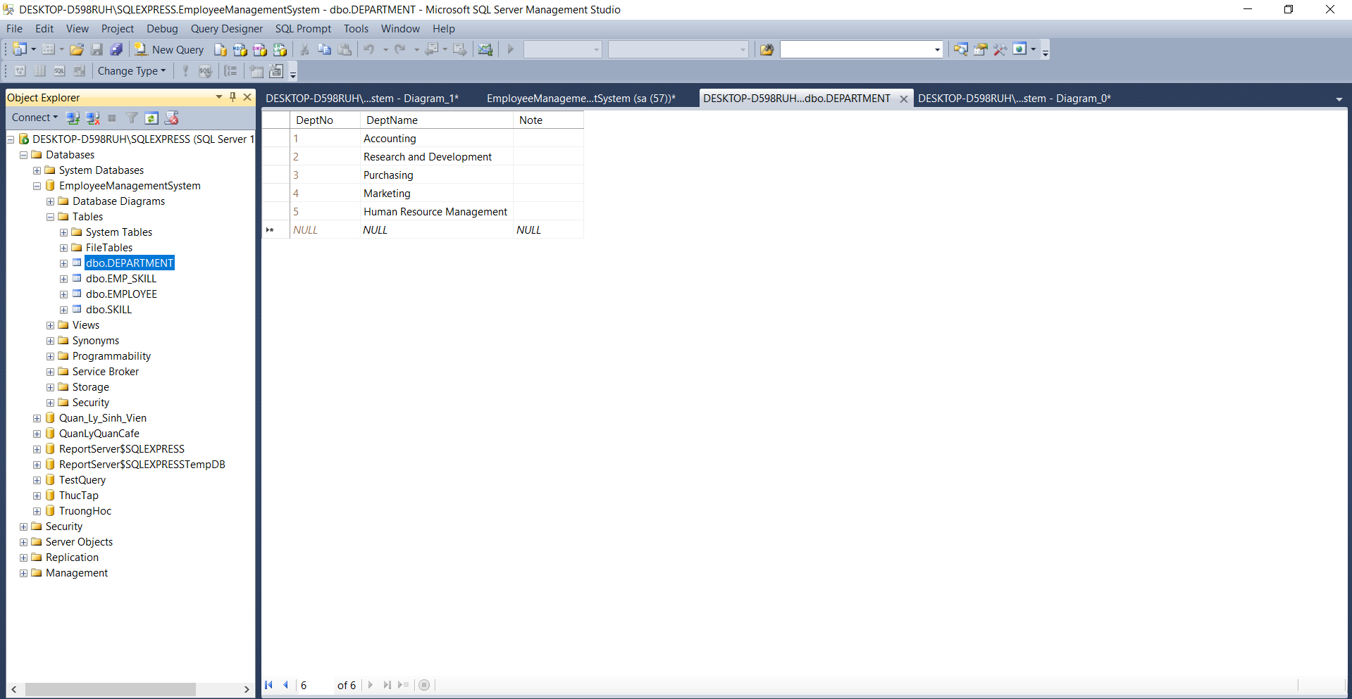

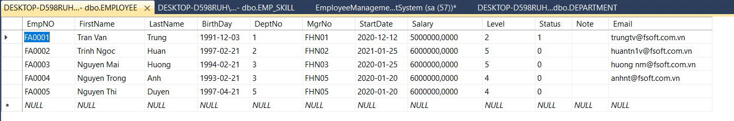

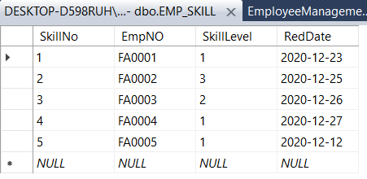

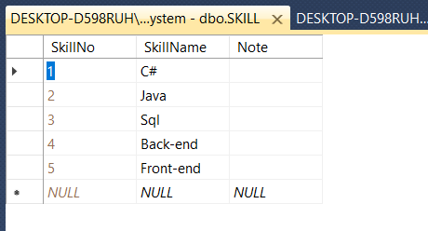

1. Create a VIEW called EMPLOYEE_TRACKING that will appear to the user as EmpNo, Emp_Name and Level. It has Level satisfied the criteria: Level >=3 and Level <= 5.

CREATE VIEW EMPLOYEE_TRACKING AS

SELECT dbo.EMPLOYEE.DeptNo, dbo.EMPLOYEE.EmpNO, dbo.EMPLOYEE.Level

FROM dbo.EMPLOYEE

WHERE dbo.EMPLOYEE.Level >= 3

AND dbo.EMPLOYEE.Level <= 5